

**RIGA TECHNICAL UNIVERSITY  
Faculty of Computer Science and Information Technology**

**Institute of Applied Computer Systems**

**“Algorithmization Practice”**

TASK OF INDIVIDUAL WORK  
**"DIP108- Algorithmization Practice”**

**Accomplished:** Student Name **Student Card No:** 121*****

2020/2021

**Index**

1. Assignment 3

2. Assignment 15

3. Assignment 31

4. Assignment 33

5. Bibliography 34

# Assignment

## Develop four algorithms to improve maths grade in school

Students need to follow 5 steps and need to create the four different possible algorithms for the above problem. ( students can skip step no 4 / programming task is not compulsory ).

**Algorithm 1**

|  |  |  |
| --- | --- | --- |
| Step | Variables | Comments |
| 1. Understand the Problem | Survey, Teaching Methods | Algorithm 1 considered two variables |
| 2, Formulate a Model |  | I used rectangular box for my model |
| 3. Develop an Algorithm |  | Algorithm 1 is developed |
| 4. Write the Program | I know programming I wrote program | I don't know programming I wrote algorithm steps only. |
| 5. Test the Program |  | Results are good |
| 6. Evaluate the Solution |  | I feel my solutions is good only for Survey, Teaching Methods variables. I think I need to take more variable |

**Step 3: Example Algorithm**

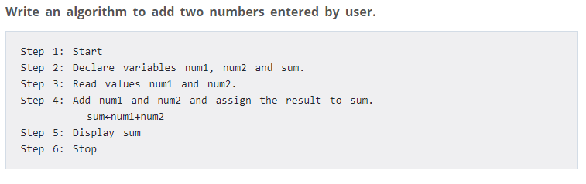

**Step 4: Example Program**

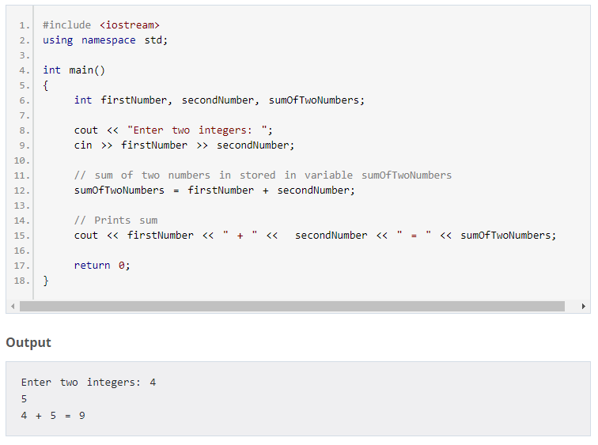

# Assignment

# 3.Bibliography

1. Solomencevs A. *The Model Transformation for Getting a UML Class Diagram from a Topological Functioning Model -* <https://ortus.rtu.lv/science/en/publications/20393/fulltext>